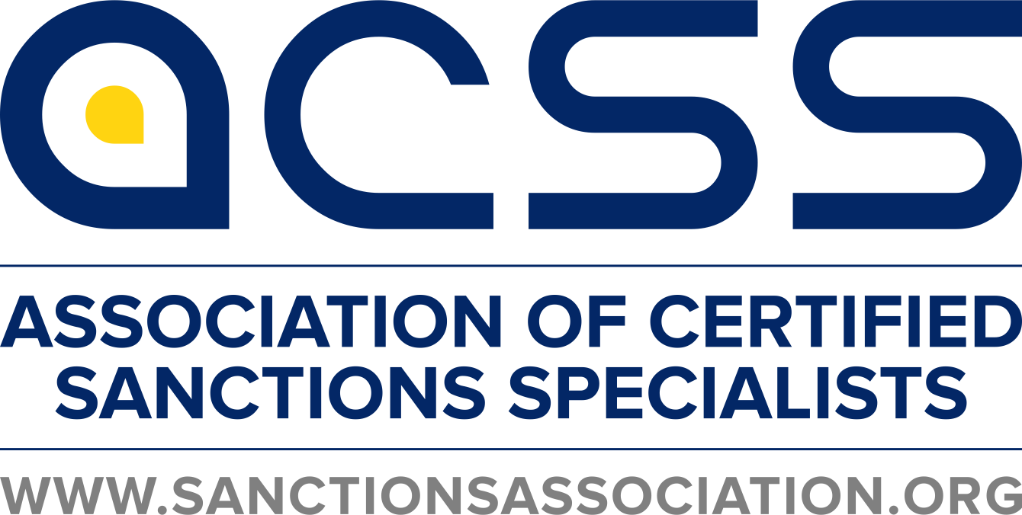

**EU Sanctions Essentials Online Certificate Course**

**Participant Guide**

**2022**

**Disclaimer**

Virtual Classrooms will be recorded with permission and is furnished for informational use only. Neither the speakers, contributors, nor the Association of Certified Sanctions Specialists is engaged in rendering legal nor other expert professional services, for which the outside competent professionals should be sought. All statements and opinions contained herein are the sole opinion of the speakers and subject to change without notice. Receipt of this information constitutes your acceptance of these terms and conditions.

**Copyright Notice – Use of Access Credentials**

@2022 by Association of Certified Sanctions Specialists, LLC. All rights reserved

Each registration entitles one registrant a single connection to the Briefing by Internet and/or telephone from one room where an unlimited number of participants can be present. Providing access credentials to another for their use, using access credentials more than once, or any simultaneous or delayed transmission, broadcast, re-transmission or re-broadcast of this event to additional sites/rooms by any means (including but not limited to the use of telephone conference services or a conference bridge, whether external or owned by the registrant) or recording is a violation of U.S. copyright law and is strictly prohibited.

**Please contact ACSS if you have any questions about this resource or about membership in the Association of Certified Sanctions Specialists (ACSS)**

**Association of Certified Sanctions Specialists**

7950 NW 53rd Street

Suite 337, Miami, FL 33166

www.sanctionsassociation.org

Tel. 305 433 7187

Email: [helpdesk@sanctionsassociation.org](mailto:helpdesk@sanctionsassociation.org)

Twitter: @ACSS_Sanctions

**Table of Contents**

Table of Contents

About ACSS IV

Certificates of Attendance and CE Credits IV

Helpdesk V

About this Course V

Why this course? V

Target audience V

What is it? V

How it is structured? VI

**Technical Requirements** VIII

**PLEASE READ ALL THE ENCLOSED MATERIAL PRIOR TO STARTING THE COURSE.**

# About ACSS

The Association of Certified Sanctions Specialists is an international membership organization that provides a platform for career development and professional networking for individuals and is a resource for financial institutions and related businesses to identify and locate specialists in the rapidly expanding sanctions field.

**Contact information:**

ACSS

7950 NW 53rd Street, Suite 337 | Miami, FL 33166

Tel. 305 433 7187 | [helpdesk@sanctionsassociation.org](mailto:helpdesk@sanctionsassociation.org) | Twitter: @ACSS_Sanctions

[www.sanctionsassociation.org](http://www.sanctionsassociation.org/)

# Certificates of Attendance and CE Credits

For a certificate of attendance after your virtual classroom, contact us at

helpdesk@sanctionsassociation.org

This course has been accredited with 7 CSS credits. At times, ACSS requests other associations’ Continuing Education credits. Some associations require you to attend the virtual classroom live to be able to receive credits. Please contact us at [helpdesk@sanctionsassociation.org](mailto:helpdesk@sanctionsassociation.org) if the class qualifies or more information.

# Helpdesk

**Helpdesk**

helpdesk@sanctionsassociation.org

+1-305-433 7187

# About this Course

### **Why this course?**

In order to meet the need for more in-depth training on European restrictive measures (sanctions)and mitigate the risk of costly EU sanctions violations, ACSS has developed an online training program, which teaches vital principles and risk management and background all sanctions compliance staff should understand.

This course is *not* an awareness course for general staff, but tailored to needs of compliance professionals.

Part of this course is self-paced, and part of this course is attending a live virtual classroom.

### **Target audience**

* Compliance Officers
* MLROs
* Audit staff tasked to evaluate sanctions programs
* EU Regulators
* United Nations staff or Panel of Experts
* OFAC/sanctions investigators
* General Counsels
* Staff in charge of sanctions
* Compliance Managers

### **What is it?**

The Course is a 7-part course, consisting of approximately 7 training hours, across 4 weeks. The course is delivered in an online format.

### **How it is structured?**

The course can be completed online, and consists of 7-parts:

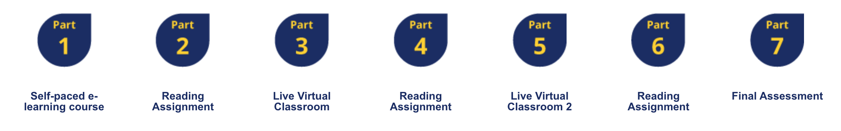

#### PART 1: Self-Paced E-Learning Course: EU Sanctions Foundations

This is a 30-minute self-paced e-learning course on the ACSS Learning Management System (LMS), which covers Foundations:

* Scenario -What Can Possibly Go Wrong?
* Introducing EU Restrictive Measures
* Framework and Legal Basis
* How do EU Restrictive Measures Come About?
* Effect of a Designation
* Who Must Comply and What Happens if You Don’t?
* Learning more: A virtual tour of EU website pages -where to find useful information
* What have we learned today?

Part 1 will be available one week before the live virtual class- Must be completed by the 1st live virtual class.

#### Part 2: Reading Assignment (30 minutes)

“Home Work Assignment” This will be PDF “Preparatory Reading for the First Virtual Classroom Session” with on key terms and definitions participants need to read to prepare for Virtual Class 1.

Part 2 must be completed before the 2nd Virtual Class

#### PART 3: Virtual Classroom #1: Policy, Legal Authorities and Core Programs (1 hour and 30 minutes)

Participants will receive a log in via email. We use GotoTraining from Citrix. See below in this participant guide for technical requirements and how to test your system.

**If you miss the live session, you must see the recording of the missed class on our platform before you start Part 4. It will be available a few days after the live session.**

Interactive live virtual classroom (webinar with interaction, Q&A sessions, and practice questions -these are just for practicing).

* EU Policy and Legal Authorities of Restrictive Measures, Art. 29 TEU and 215 TFEU, plus CFSP
* Sources of EU sanctions: autonomous vs. UNSC-based
* Anatomy of a EU Sanctions Regime and how they are implemented
* Categories of EU Restrictive Measures, including trade restrictions such as common military list, financial restrictions/asset freezes, plus restrictions on admission, with examples
* Circumvention and how to preven this – with case study
* Key Programs (e.g. Iran, Russia) and recent guidance
* Blocking Statute
* Program contains exercises/case studies/and audience polls, plus quiz practice questions
* Q&A with audience

#### PART 4: Reading Assignment (30 minutes)

A PDF, containing key terms and definitions participants need to read to prepare for Virtual Class 2.

This will be available one week before the 2nd virtual class (part 5)

#### PART 5: Virtual Classroom #2: Implementation, Listing, Licensing and Enforcement (90 minutes)

You will receive a log in via email. We use GotoTraining from Citrix. See below in this participant guide for technical requirements and how to test your system.

**If you miss the live session, you must see the recording of the missed class on our platform. It will be available a few days after the live session.**

Interactive live virtual classroom (webinar with interaction, such as case studies, Q&A sessions and practice questions.)

* Implementation of EU Restrictive Measures: EU Council Decisions vs Regulations, with exercises, precedence over conflicting domestic legislation and compliance
* Listing process with Decision of the Council, and following steps: Where to find the list; Delisting process
* Member states’ own lists
* Exemptions with case studies
* Who must comply with EU Sanctions
* Elements of a sound compliance program, relevant guidance from the EU
* Determining sanctions risk (e.g. business relationship initial vs. on change of relationship, ownership/control, products, transaction due diligence)
* 50% rule - What are factor indicating control
* EU Iran Sanctions Tool and Helpdesk
* Freezing of Funds and “Economic Resources”
* Short exercises /case studies/practice questions
* Q&A with Audience

#### PART 6: Reading Assignment (30 minutes)

Case study with questions for the participants. Must be submitted on the platform.

#### PART 7: Final Assessment (45-minutes)

Online Quiz: This is a multiple question quiz in multiple choice format. The quiz is posted on our LMS. It will be available after your complete Part 1-6. You can take the quiz up to 3 times. You have one month to take the quiz. You need to successfully pass the quiz in order to complete the course and obtain the **Certificate of Completion.**

### **Technical Requirements**

Our learning course works better with a chrome browser.

**Gototraining:**

We use gototraining as our virtual training platform. Normally, this service downloads an application to your computer. If you are using a company computer and cannot download the application onto you computer, please bring up the invitation link using a **chrome** browser. We have setup the event so that participants using the chrome browser do not download the application.